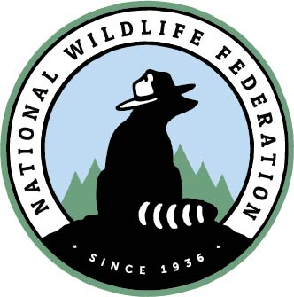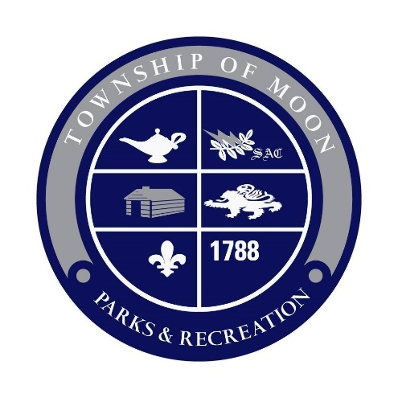
Media Contact: Cait Fallon, National Wildlife Federation, FallonC@nwf.org, 303-441-5167
Local Contact: Lisa Shaughnessy, Moon Township Parks and Recreation, lshaughnessy@moontwp.us, 412-262-1703 ext 403
Moon Township Joins Movement to Become a Wildlife-Friendly Community

Moon Township, March 17. 2023 – The community of Moon Township is launching a new partnership with the National Wildlife Federation’s Community Wildlife Habitat™ program to become a healthier, greener, and more wildlife-friendly by committing to create wildlife habitat throughout its communities while also educating and engaging residents.

Healthy habitats and healthy communities go hand-in-hand. Too often communities are suffering from pollution, disinvestment, or other challenges that separate people from the natural world. When human communities suffer, wildlife suffer as well.

“By joining the National Wildlife Federation’s Community Wildlife Habitat program, Moon Township is sending a clear and powerful message to communities all over America that people working together can create healthy habitats and healthy communities and make a difference in their own community and beyond,” said Patrick Fitzgerald, Senior Director of Community Wildlife.

Moon Township is taking steps to meet the requirements to achieve this certification in areas of outreach, education, and more. Residents of Moon Township can help by certifying their own gardens and yards through the Certified Wildlife Habitat program. Schools, businesses, churches, and HOAs are encouraged to participate in this exciting venture as well. Each residence and organization that is certified will help the Township reach its goal. Additionally, the Moon Township Garden Club is encouraging residents to participate in the “Pollinator Pathways’ Million Pollinator Garden Challenge.” Moon Township’s efforts with pollinators and the Community Wildlife Habitat program will work hand in hand preserve and enhance the green spaces of our community.

“We are excited to start this certification process,” says Lisa Shaughnessy, Youth Program Coordinator for Moon Parks and Recreation. “We have already begun projects in some of our parks, like converting lawn areas to meadows with native plants, as well as nature programming for ages 3-12 and our annual Earth Day event. All these efforts will be essential to reach Community Wildlife Certification, which we hope to complete in 1-2 years.”

Since 1973, the National Wildlife Federation has provided millions of people with the basic guidelines for making their landscapes more hospitable for wildlife. To date, through the Certified Wildlife Habitat™ program, the National Wildlife Federation has certified more than 250,000 sites including yards, schools, businesses, community gardens, parks, and places of worship. Each of these sites provides the four basic elements that all wildlife need to thrive: food, water, cover and places to raise young, while integrating sustainable gardening and landscaping practices.

To become certified as a National Wildlife Federation Community Wildlife Habitat™ Moon Township is calling on its residents to certify their own property at NWF.org/Certify and join our education and outreach efforts to learn about how residents can create a healthier, greener and more wildlife-friendly community. Join us at our Earth Day kick off event at Moon Park on April 23, from 1-3pm.
***
About Moon Parks and Recreation

The mission of the Moon Parks & Recreation Department is to advance parks, recreation, and environmental conservation efforts that enhance the quality of life for present and future residents of Moon Township as well as provide diverse and leisure opportunities through programs, facilities, and services. The Moon Township Parks & Recreation Department offers residents an array of social, cultural, and athletic programs throughout the year. With a strong emphasis on maintaining “green space” in the community, the Parks & Recreation Department oversees over 600 acres of park space including the 300+ acre Moon Park, Robin Hill Park with over 200 acres, and Olson Park & Boggs School with over 100 acres.

For more information about Moon Parks and Recreation please visit www.moonparks.org. Follow us on Facebook and Instagram.
***
For more information about the National Wildlife Federation’s Community Wildlife Habitat network, please go to: www.nwf.org/community.

For more National Wildlife Federation news, visit: www.nwf.org/news.

The National Wildlife Federation is America's largest conservation organization, uniting all Americans to ensure wildlife thrive in a rapidly changing world. Follow us on Facebook, Twitter, and Instagram.
###

